**GRAND BALI HOTEL – NUSA DUA**

**Key Investment Highlights**

Hotel was built on 1 ha land (15,000 M2 GFA)

+ Total 63 keys

* 54 x Standard Suite 52 M2
* 6 x Premium 85 M2
* 3 x Pool Villas 125 to 200 M2

Additional land available for development:

1. 1 Ha (40% Hak Milik and 60% HGB (under BTDC))
2. 1.3 Ha (100% Hak Milik) along the golf hole 1

See Google map below with the hotel (shown by the yellow arrow line) and the two additional parcels of land (in red outline).

The hotel was built in 1999 and acquired in 2004 by the present owner. A full renovation of the hotel was conducted in 2014.

The Hotel land certificate is HGB 30 years until 2026 which will be automatically renewed for another 20 years with very small registration fee for every 20 years similar to the standard practice for every HGB land.

The owner is open to any best solution, or to sell the hotel and adjacent lands or to make a JV with a potential investor who could be interested to own the hotel and invest in the extension development. The owner is keen to deal with Euro Asia Group & Colliers to keep the control of the design, development and to market the units. There is a possibility to develop 350 mixed apartment units.

The extension in the 1 Ha land could be in a form of holiday apartments (1, 2 and 3 bedrooms apartment) marketed under Vacation Club (Timeshare).

Regarding the 1.3 Ha along the golf hole 1, Euro Asia Group has the idea to develop a luxury holiday residence and they already have a plan to brand and operate this property who could be disconnected from the current Grand Bali Hotel. Part of the units will be put up for sale under full ownership to Indonesian owners and part under Fractional ownership.

Euro Asia Group has already engaged serious discussion with two major hospitality groups interested to brand and operate the Grand Bali Hotel as it is and to brand, market and operate the Vacation Club.

The proximity with the golf club House, next to St Regis Bali Resort, Mulia Resort and future Shangri-La and access to a private beach next to the Grand Hyatt Hotel Nusa Dua gives a very good value of the property. There is further value creation provided by the additional land development opportunity.

The asking price for the hotel, together with the 2 pieces of land is US$ 58Mil (neg).

1

**General Location of Property**

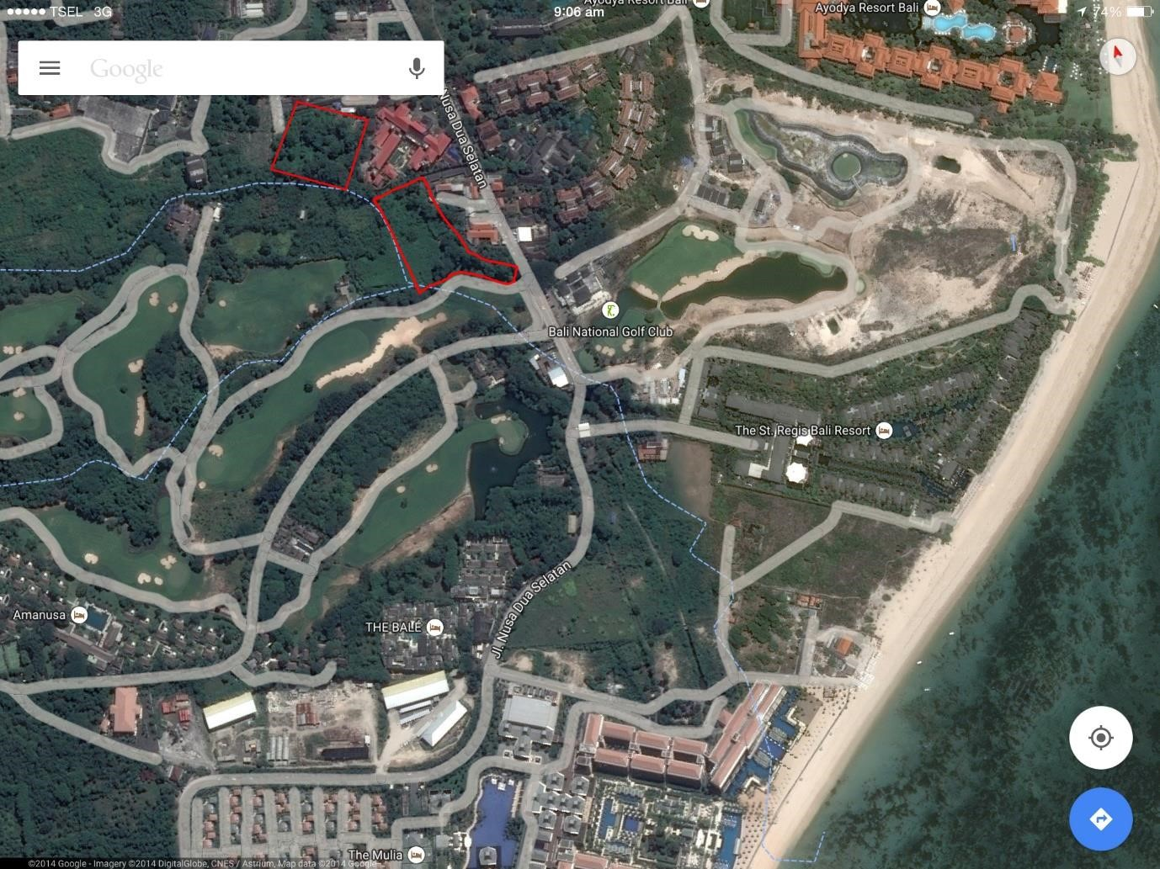

Grand Bali Hotel Nusa Dua

Mulia Hotel

St Regis

Hotel

Shan

g

ri

-

La

Hotel

(

under

construct

ion)